**Homework 3**

**COM S 362**

**Fall 2021**

You are asked to perform an analysis of a system that will manage all aspects of a Catering Event Panning business. Use this first-hand expert account to base your analysis: http://becomeaneventplanner.org/catering-event-planner-job-description.html

You may incorporate information from other sources but focus on including what you have learned from the domain expert’s account.

**Important:** you are expected to follow all conventions and best practices for use cases given by Larman, specifically in Ch. 6.

1. **(20 points)** Provide the name of at least ten use cases for the Catering Event Planning System.
   * Use Case 1: Creating a Menu
   * Use Case 2: Doomsday Preparations
   * Use Case 3: Hire Staff
   * Use Case 4: Purchase Equipment
   * Use Case 5: Site Planning Trips (Design)
   * Use Case 6: Purchase Food
   * Use Case 7: Create Invitations
   * Use Case 8: Purchase venue decorations
   * Use Case 9: Plan of Service (food)
   * Use Case 10: Chose and order Entertainment

1. **(40 points)** Using the template shown below, complete two “fully-dressed” non-trivial (more than five steps in the main scenario) use cases from the list you created for Problem 1. Do not worry about exceptional and alternate scenarios. Use precise language for each step in the main scenario.

* **Use Case name: Creating a menu**
* **Primary Actor**: Event Planner
* **Stakeholders and Interests:**
  + **Client/Event Host**: wants to create a delicious menu for the party that everyone will like and enjoy
  + **Event planner**: Customer Satisfaction and creating/holding a good track record of creating and serving good items
  + **Attendees**: Want to be served a good meal that won’t inhibit them any anyway (food poisoning, allergies, etc)
  + **Chef/Kitchen Staff**: Wants to know the Client would like to be served. Will also give insight into equipment and staff responsibilities
* **Preconditions:** The event planner and Client had a meeting to discuss what theme for the food should be, any known allergies or if there is a preference when preparing any of the food items.
* **Success Guarantee:** Menu is created that client, chef and event planner are satisfied with, and food preparations can begin to be made (ordering items)
* **Main Success Scenario:**
  + Event planner holds meeting with desired chef and client about a specific item to serve
  + Client addresses wants and concerns about items
  + Rough outline of the meal course
  + Menu Refinement meeting with Event planner and Chef is held to have specifics about food and what silverware and plating will be need
  + Event planner takes Menu to Client
  + Event planner creates menu cards of the items to be served meeting with the client to and refining until desires are met
  + Event planner gets estimates on cost of menu
  + Repeat above step until estimate is within clients desires

* **Use Case name: Doomsday Preparations**
* **Primary Actor: Event Planner**
* **Stakeholders and Interests:**
  + **Client/Event Host:** wants to host an event that will go smoothly with out any major issues to which their guest will leave satisfied and pleased.
  + **Attendees:** want to a attend an event that doesn’t seem cheap, poorly managed or unattractive to the human eyes.
  + **Kitchen/Serving staff** are interested in receiving good reviews about their service and food.
  + **Event planner:** Uphold a good reputation of planning and accomplishing events and meet the customers desires and run smoothly.
* **Preconditions:** The decorations for the venue, location, date, menu and service have all been discussed and planned out. Doesn’t have to be fully implemented but needs its foundation.
* **Success Guarantee**: The event is happening with little to no issues or such that any issue that arises will have a resolution/plan of actions based on prior planning.
* **Main Success Scenario:**
  + Event planner will go over the flow of action items the day of the event.
  + Event planner will start a list of solutions for various problems that could arise.
  + Once a clear flow is created event planner will meet with head chef to see what could go wrong, and what will make the event go smoothly. Then in worst case scenario how can things keep moving.
  + Event planner will meet with servers to see what will help make things go smoothly and evaluate an weak points in service or things that could cause problems.
  + Once this is done a solution to problems and worst-case scenarios is jotted down.
  + Event planner will meet with moving crew about how long it will take to set up to plan ahead leaving extra time incase someone gets hurt or things take longer.
  + Event planner will keep going over ever action item in the event until various problems and solutions are listed for each one.
  + According to schedule Event planner will begin assigning specific tasks for individuals to set up event
  + Event Planner will assist where needed (kitchen, decoration set up, entertainment check, etc)
  + Event planner will do final check that entertainment is functioning properly and that kitchen preparations are on time
  + Event Planner will assist servers in seating the guest.
  + In the case that something where to go wrong event planner will go over the dictionary of resolutions to problems
  + Event finishes with any problems that have arisen being addressed by the solution dictionary or on the spot fix.

1. **(20 points)** Create a use case diagram with the ten use cases you identified in Problem 1.

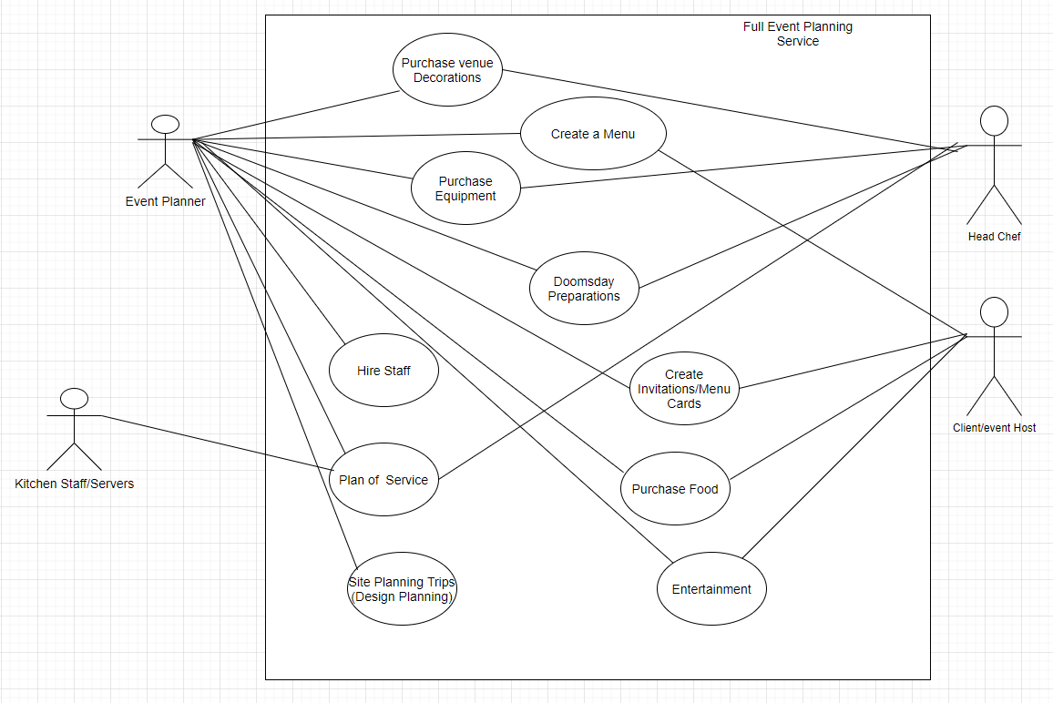

1. **(20 points)** In your own words, provide reasons/examples that justify Larman’s assertion that use cases are more valuable than use case diagrams. In your explanation address the following questions. What purpose does a use case serve in the analysis and design process? What purpose does a use case diagram serve in the analysis and design process? 60 to 120 words.

**Answer**: Use cases are more useful than use case diagrams because it allows many stakeholders to partake in requirement discussions. It also very clearly states the use case in natural language that most can understand easily. Use case diagrams take more time to develop and can cause confusion since the relationship between other use cases and actors are also shown in the diagram. (Overload of information) The Use case diagram allows for the easy naming of the use cases, and it also gives a good picture of a context diagram of the system. The “context diagram” shows all the actors and how they interact with the system. Uses cases serves as the backbone when designing and making sure the software meets the requirements and then when going back test cases can be made from the uses cases to ensure that the software does indeed meet the requirements.